CS 499
Professor Martinez
Colette Nole
29 March 2026

4-2 Milestone Three: Enhancement Two: Algorithms and Data Structure

Artifact: SNHU Travel System (Enhanced)

1. Briefly describe the artifact. What is it? When was it created?
The artifact used for this enhancement is the SNHU Travel System, a Java-based application originally developed during CS 250. a Java application originally developed for CS 250 in 2024. While Milestone Two focused on the "how" (Software Engineering), Milestone Three focuses on the "what" (Algorithms and Data Structures). The software displays a travel destination list using a custom renderer for icons and text.

2. Justify the inclusion of the artifact in your ePortfolio. Why did you select this item? What specific components of the artifact showcase your skills and abilities in software development? How was the artifact improved?
I selected this artifact to showcase my ability to manipulate data efficiently. In the original version, the destinations were stored in a static, hardcoded order with zero flexibility.
To enhance the artifact, I replaced the static data structure with a dynamic ArrayList, allowing the application to scale beyond a fixed number of destinations. I also implemented a sorting algorithm using Java’s Comparator to automatically organize destinations alphabetically.
These improvements demonstrate my ability to apply core computer science concepts to solve practical problems. The application now behaves more like a real-world system by organizing data dynamically and presenting it in a structured and predictable way.
Figure 1. Transition from static data storage to a dynamic ArrayList, enabling the application to scale beyond a fixed number of destinations.
Figure 2. Implementation of a sorting algorithm using Comparator to organize destination data alphabetically.
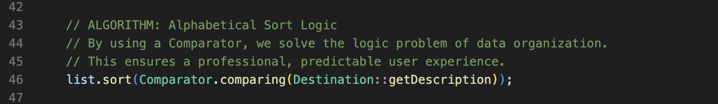

3. Did you meet the course outcomes you planned to meet with this enhancement in Module One? Do you have any updates to your outcome-coverage plans?
This enhancement aligns primarily with Course Outcome 2; I evaluated the limitations of static data storage and moved to a dynamic model. By implementing an alphabetical sort, I demonstrated my ability to solve a logic problem using algorithmic principles, managing the trade-off between simple code and functional power.
Additionally, this work supports Course Outcome 4, as I utilized the Java Collections Framework to implement an efficient and scalable solution. The use of built-in tools such as ArrayList and Comparator reflects industry-standard practices in software development.

4. Reflect on the process of enhancing and modifying the artifact. What did you learn as you were creating it and improving it? What challenges did you face?
Through this enhancement, I gained a deeper understanding of how data structures influence application performance and scalability. My background in software testing has shown me how systems can fail when they are not designed to handle growth, and this project reinforced the importance of planning for scalability early in development.
One challenge I encountered was ensuring that the sorting logic was correctly applied before the data was passed to the user interface. This required careful separation of concerns between the service layer and the presentation layer. Overcoming this challenge helped reinforce my understanding of clean architecture and the importance of organizing code effectively.
Overall, this process strengthened my ability to think critically about how data is managed within an application and how algorithmic improvements can enhance both functionality and user experience.

